**Experiment No. 2**

**SAP Id: 500083382**

**Batch: B5**

**Name of the Student: Anurag Singh**

**Title**: Design program using array and pointer

1. Define two array and store and traverse the array

**Code:**

#include <stdio.h>

#include<malloc.h>

int main()

{

    // Define two pointer array to store the input data

    int *arr1 = NULL;

    int *arr2 = NULL;

    // Take the input from the user

    int length1, length2;

    printf("\nEnter the length of the first array: ");

    scanf("%d", &length1);

    printf("\nEnter the length of the second array: ");

    scanf("%d", &length2);

    // Allocate memory for the array

    arr1 = (int *)malloc(sizeof(int) * length1);

    arr2 = (int *)malloc(sizeof(int) * length2);

    // Take the input from the user

    printf("\nEnter the elements of the first array: ");

    for (int i = 0; i < length1; i++)

    {

        scanf("%d", &arr1[i]);

    }

    printf("\nEnter the elements of the second array: ");

    for (int i = 0; i < length2; i++)

    {

        scanf("%d", &arr2[i]);

    }

    // Print the input data

    printf("\nThe first array is: ");

    for (int i = 0; i < length1; i++)

    {

        printf("%d ", arr1[i]);

    }

    printf("\nThe second array is: ");

    for (int i = 0; i < length2; i++)

    {

        printf("%d ", arr2[i]);

    }

    return 0;

}

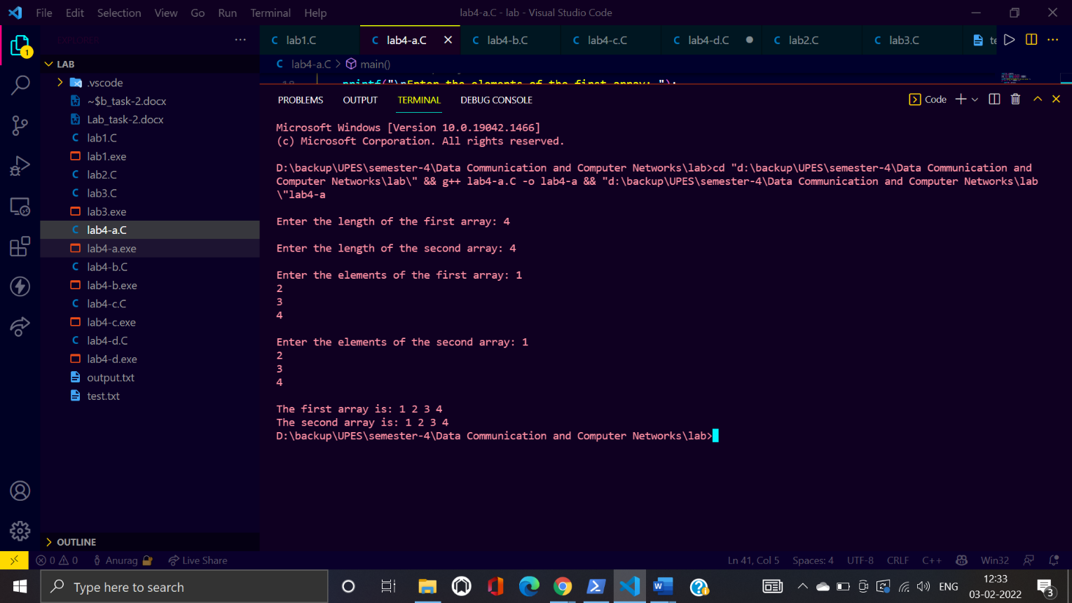**Screenshot:**

1. Find the element inside the array

**Code:**

#include<stdio.h>

#include<malloc.h>

int main()

{

    // find element in pointer array

    int *arr1 = NULL;

    // Take the input from the user

    int length;

    printf("\nEnter the length of the first array: ");

    scanf("%d", &length);

    // Allocate memory for the array

    arr1 = (int *)malloc(sizeof(int) * length);

    // Take the input from the user

    printf("\nEnter the elements of the first array: ");

    for (int i = 0; i < length; i++)

    {

        scanf("%d", &arr1[i]);

    }

    // search element

    int element;

    printf("\nEnter the element to be searched: ");

    scanf("%d", &element);

    int flag = 0;

    for (int i = 0; i < length; i++)

    {

        if (arr1[i] == element)

        {

            printf("\nElement found at index %d", i);

            flag = 1;

            break;

        }

    }

    if (flag == 0)

    {

        printf("\nElement not found");

    }

    return 0;

}

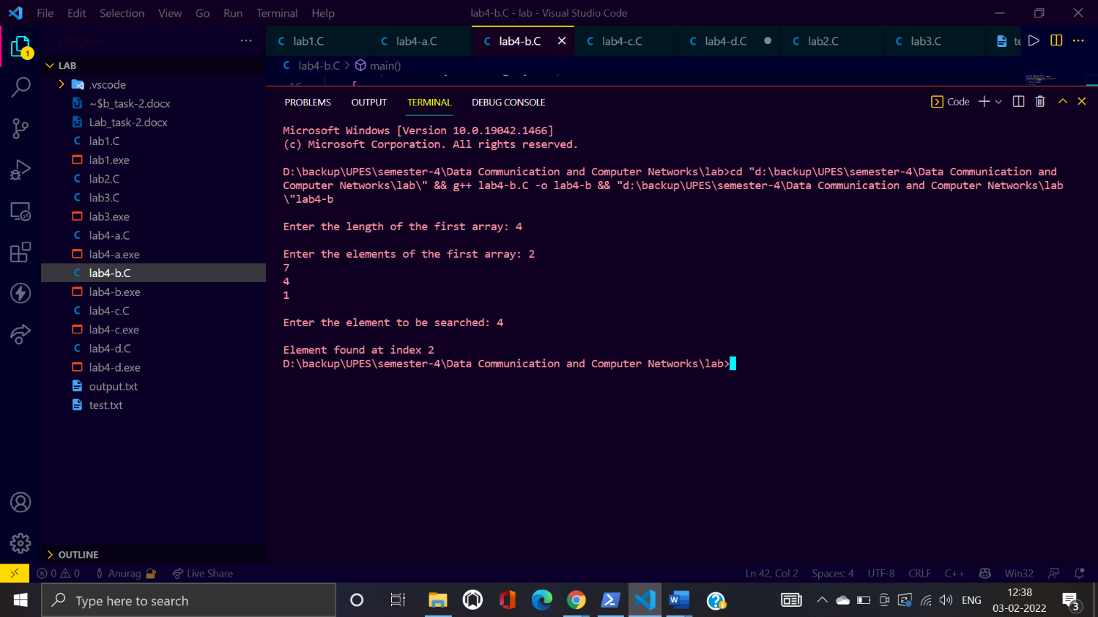**Screenshot:**

1. Program for reading and writing string

**Code:**

#include<stdio.h>

int main()

{

    // string writing and reading

    char str[100];

    printf("Enter the string: ");

    scanf("%s", str);

    printf("\nThe string is: %s", str);

    return 0;

}

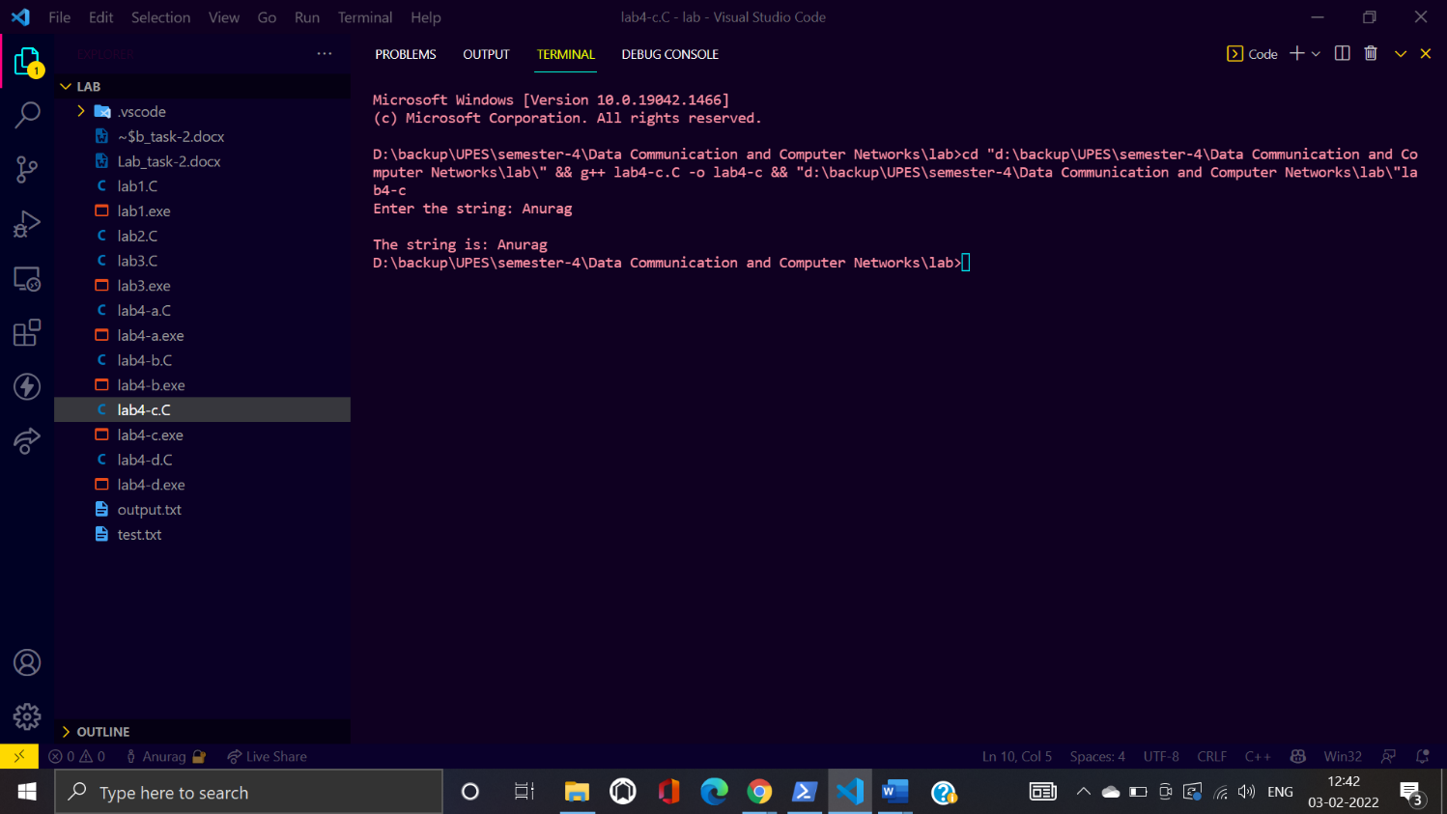**Screenshot:**

1. Add two string

**Code:**

#include<stdio.h>

#include<string.h>

int main()

{

    // add two  strings

    char str1[100];

    char str2[100];

    printf("Enter the first string: ");

    scanf("%s", str1);

    printf("Enter the second string: ");

    scanf("%s", str2);

    printf("\nThe first string is: %s", str1);

    printf("\nThe second string is: %s", str2);

    int length1 = strlen(str1);

    int length2 = strlen(str2);

    char str3[100];

    int i = 0;

    for (i = 0; i < length1; i++)

    {

        str3[i] = str1[i];

    }

    for (int j = 0; j < length2; j++)

    {

        str3[i] = str2[j];

        i++;

    }

    str3[i] = '\0';

    printf("\nThe concatenated string is: %s", str3);

    return 0;

}

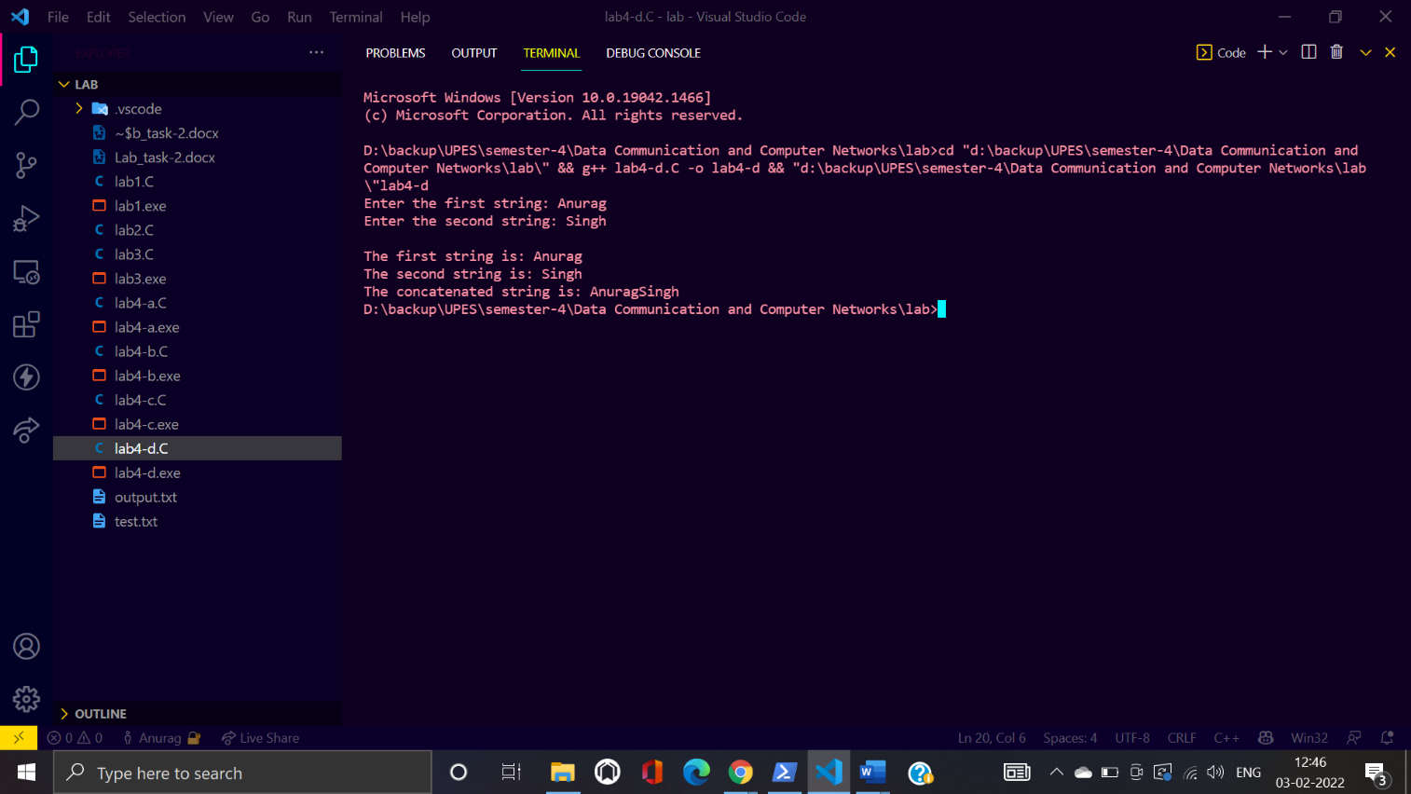**Screenshot:**